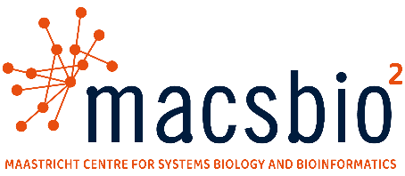
Showing science through code: animation in Python
Jelle Bonthuis (jelle.bonthuis@maastrichtuniversity.nl) &
Daan van Beek (d.beek@maastrichtuniversity.nl) &
Michiel Adriaens (michiel.adriaens@maastrichtuniversity.nl) &
Marian Breuer (marian.breuer@maastrichtuniversity.nl)
Level: 3000 Min - max. no. students: 4-12
At MaCSBio² we have developed several complex multi-step algorithms that process and manipulate data. These algorithms are often difficult to explain, requiring mathematical notations and supplementary files for elucidation inside publications, while presentations often hand-waive complexity and provide static or unintuitive explanations. In addition, collaborators might misunderstand or forget details discussed during meetings, thereby requiring more time investment from both parties to clarify. Instead, ready-made videos that can be updated or modified after algorithm changes, and which show each step in an intuitive and aesthetically pleasing manner would be ideal for science communication.

To this end, this project will focus on creating such videos using Manim, a Python library for animating educational videos, created by the mathematician and Youtuber 3Blue1Brown. Students will be provided detailed explanations of one (or more) algorithms, and links to tutorials on using Manim to create animations. From here, students will create a storyboard and subsequently focus on different parts of the scenes/components they deem necessary to accurately and intuitively convey the methodology. Voicing over the video is not required and preferably avoided in favour of more visual explanations.

While Manim is a Python-based library and programming skills are required to create videos using it, the project does not require a deep understanding of software design and development. Nevertheless, custom-made animation styles will still give more advanced (programming-wise) students the opportunity to apply their knowledge to solve complex issues. Simultaneously, as this project focuses on novel work related to metabolic modelling, students will become acquainted with our novel methodologies.

If successful, the final product will be hosted online on the MaCSBio² Youtube channel and shared with potential collaborators. It will additionally serve as a tangible accomplishment that can be shared with potential employers or interested parties in mind. To be successful, basic Python proficiency (or the willingness to study beforehand), as well as an interest in storytelling and science communication is essential. As the animations created through Manim are not limited to any specific field, the skills developed in this project are thus highly transferable; however, will require an experimental and persistent mindset.

Main discipline | Systems biology/bioinformatics
Project type | Video animation through code
Keywords | Python, video animation, science communication
Other information
Please indicate where the project will take place:
☐ Maastricht: PHS PBL rooms

- We use this form to find out which groups will occupy which labs, but ask supervisors to discuss room use and scheduling.

